RoiEditor 3.0
The goal of RoiEditor is to remove “bad ROIs” from microscope images and to generate the data to perform statistics on the basic ROI properties: area and the Feret-parameters.
RoiEditor 1.0 is a Jython plug-in for Fiji and was started from the LabelsToRois plug-in. RoiEditor 1.0 and 2.0 have extended editing capabilities but lack the configurable erosion and multiple slice functionality of LabelsToRois. RoiEditor 2.0 is a standalone implementation of RoiEditor using regular Python aka CPython.
RoiEditor cannot segment cell ROIs in photographs. cellpose is used for that purpose.
- NEW | RoiEditor 3.0 can detect nucleus ROIs in cells if they can be discerned only using their color. Nuclei can be added manually, and the perimeter polygon of a nucleus can be edited.
This manual will guide you through the steps from the segmentation using cellpose to the generation of the data for further statistical analysis using RoiEditor 2.0.
An overview of the cellpose + RoiEditor workflow is shown in Figure 13 on page 16.
RoiEditor has only been tested on images of mouse muscle tissue using a small magnification (e.g. 10x).
RoiEditor has been tested on Ubuntu 24.4 LTS.
  - Acknowledgement
The team of Prof. Katrien Koppo at KU Leuven kindly granted permission to use the sample images in the TestData folder in RoiEditor.zip.
RoiImage uses a trimmed down version of Pierre Raybaut's array2d_to_qpolygonf.
TinyRoiFile is a stripped version of Christoph Gohlke's roifile.
The original article about LabelsToRois can be found on:
https://www.researchgate.net/publication/348672590_Automatic_and_unbiased_segmentation_and_quantification_of_myofibers_in_skeletal_muscle
The github site of LabelsToRois: https://labelstorois.github.io/

Installation on Windows

Get the zip
- Change folder to a folder where you are allowed to install software.
e.g. your Documents or Documenten folder
- Copy the RoiEditor.zip into that folder, there is no need to create an RoiEditor folder. The RoiEditor folder will be created when unzipping.
- Extract/Unzip the zip-file
normally you can do:
  - Right click on the zip.
  - A menu opens.
  - Select Extract all.
- Unzipping will create an RoiEditor folder and put all the files in there.

Start a command prompt
- Change folder into the RoiEditor folder.
- Double-click ‘start_prompt.bat’.
- A text window will open and a command prompt ‘>’ will appear as shown in Figure 1.
- Whenever the work is done to command prompt ‘>’ will re-appear.
- Whenever the command window gets too crowded while you are installing, you can wipe the command prompt window, by typing cls and tapping <enter>.
Figure 1: the prompt waiting for a command

Checking what’s already installed
If you do not know whether Python or cellpose are already installed, you can use the batch script check_install.bat. To run check_install.bat ,
- Type ‘check_install.bat’ on the command line
- Tap <enter>
- The screen will show what is already installed
Whenever you are in doubt about the success of the installation, you can run check_install.bat again to check what’s properly installed.

Install Python.bat
- Type ‘install_python.bat’
- Tap <enter>
- The screen will show the progress of the installation
- Wait until the installation ends and the prompt ‘>’ returns

You can choose another way of installing Python, but keep the warning below in mind:
- ! | RoiEditor 3.0 has been developed using Python 3.11 and validated for compatibility with Python 3.11. It has been tested and shown to run on Python 3.12 and 3.13. Today (Nov 2025) installing Python 3.13 requires a C development toolkit to be installed to build e.g. numpy.  For using Cellpose 3.x it is recommended to install Python 3.11.

Install RoiEditor
- Type install.bat.
- Tap <enter>.
- Colorful lines will flash on your screen.
- Wait until everything stops and the prompt ‘>_’ returns.
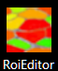
- After finishing the installation, you should be able to start RoiEditor as described in “2.2 Start RoiEditor” below.
- An icon should appear on the desktop:

Check the installation
If you want to confirm the installation has succeeded, you can repeat the steps in 1.4.
Now you are ready to use RoiEditor.

Using RoiEditor

Use

Start RoiEditor
There are a few options to start the RoiEditor:

- If the installation has run smoothly, an icon should have appeared on the desktop.
Double-clicking the icon will start the RoiEditor.
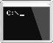
Alternatively:
- Start a windows command prompt:
- Try:
  - Python -m RoiEditor or
  - RoiEditor
- If the above do not work, change the folder to the RoiEditor folder and type:
  - Python -m RoiEditor

Select the files
The files generated by cellpose can now be imported into RoiEditor. As indicated in the columns ‘Usable combination’, one always needs to specify at least the original file and a label file.
For the label file either a .png or a _seg.npy, numpy file format, can be specified. If no zip/ROI file is specified, RoiEditor derives the information from original & label file.
File | Figure 12 | Usable combination | Usable combination
Original | A | √ | √
Label | I or II | √ | √
Zip / ROI | III |  | √
Table 1: Selecting files

Autocompletion
When the user first selects the Original file, RoiEditor will search the current folder for the ‘most probable’ candidates to be used as Label file and Zip file and select them. If this does not correspond to the intended choice of the user, the names can be wiped by clicking the trash can button.

Two in one go
When the Original file is being selected, one can select two files.

The checkboxes & radio buttons

Process Labels
Table 2 explains the function of the checkboxes in the “Choose paths and settings”>”Process labels” group box. The settings are only applied when the Next button is clicked to process the data.
While the Image Window is shown, the checkboxes have no effect.
Remove at edge | When checked, incomplete ROIs at the edges of the photograph will be removed automatically.  The deleted ROIs are tagged with ‘edge.image’.  The effect is visualized in Figure 11 on page 14.
Remove small | When checked, the ROIs smaller than the size specified in the textbox ‘Min size’ pixels will be removed automatically. The deleted ROIs are tagged with ‘small’
Table 2: Proces labels checkboxes

Unit & Scale
Table 3 explains the function of the radio buttons in the “Choose paths and settings”>”Units & Scale” group box. The settings are only applied when the Next button is clicked to process the data.
Pixel is unit | When checked, all shown lengths and areas are expressed in pixels.
From file | tif(f) image files may contain metadata about the microscope used. When the Original file has been selected and it contains the necessary data, it is shown here. When checked, the scaler read from file will be used.
Specified | The user can manually enter a scaler $\left(\frac{μm}{pixel}\right)$ converting pixel-width and height into microns. When checked the user-specified scaler will be used.
Table 3: Unit & Scale radio buttons

Next
Figure 2 shows that when the ‘Next’ button (B) is clicked after the files have been selected (A), the files will be processed taking into account the choices in the checkboxes. The result will be shown in an Image Window as shown in Figure 3. At the same time a Histogram window will appear.

Figure 2 Clicking Next after selecting files

Editing ROIs
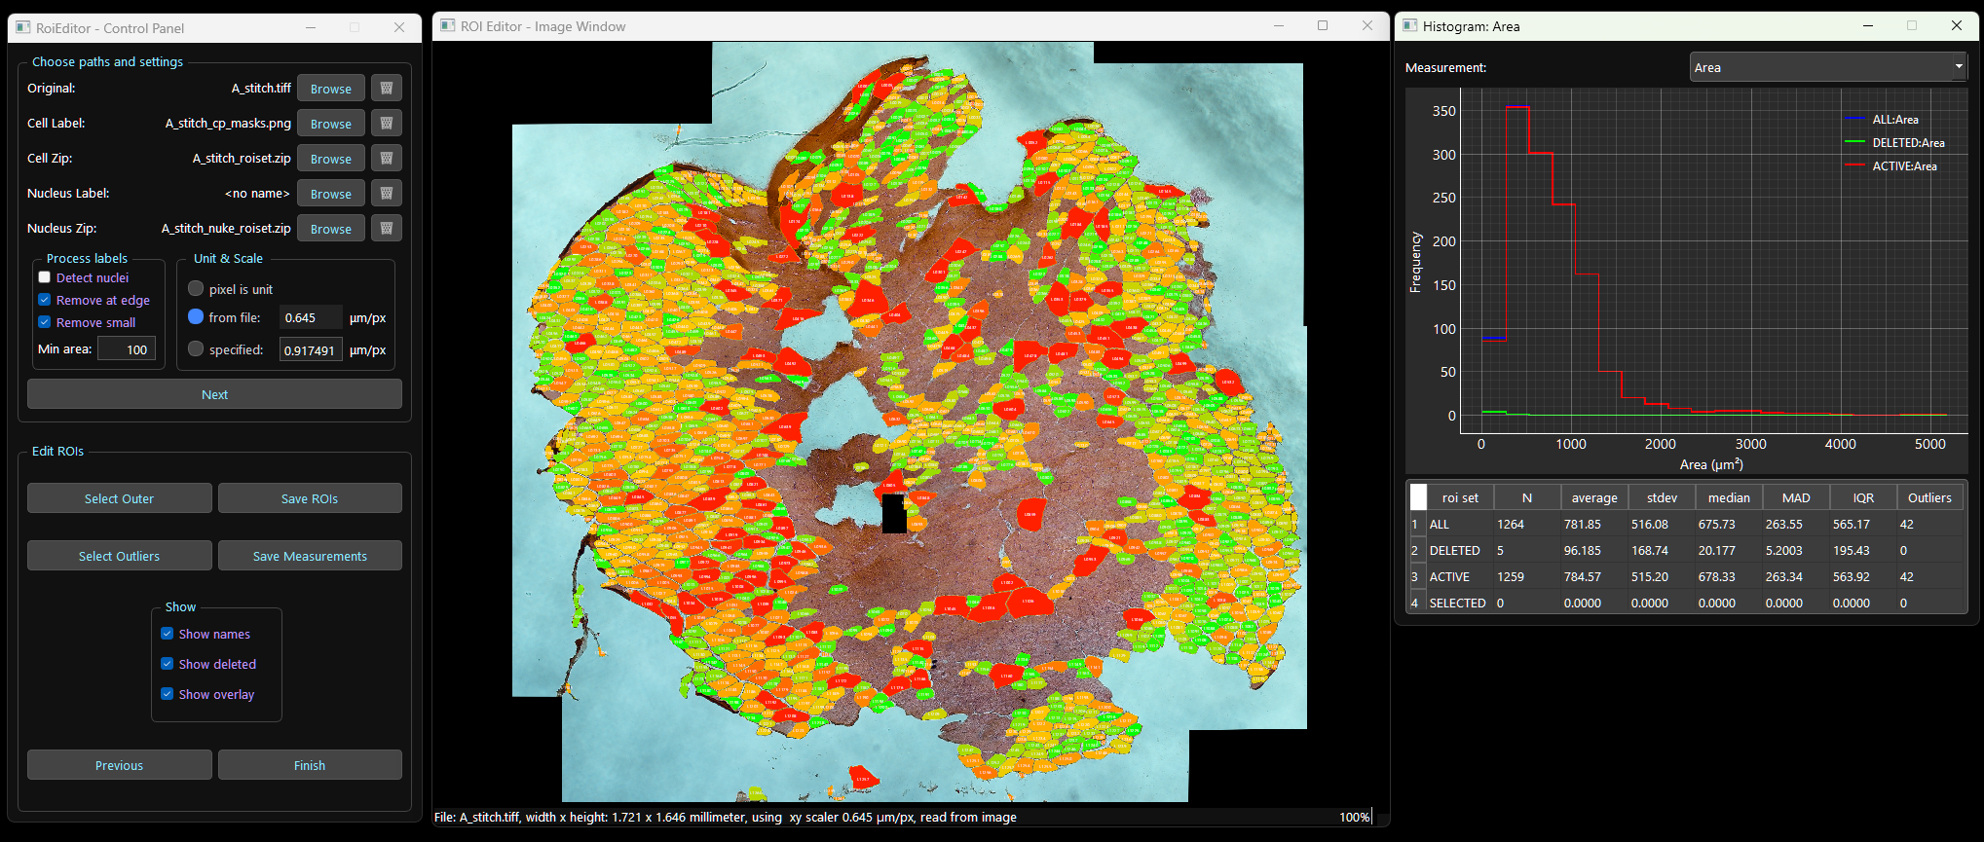
Figure 3: the context for editing ROIs

ROIs have three possible states in the RoiEditor: ACTIVE, DELETED, or SELECTED. ROIs are never removed from the output generated by RoiEditor. When the status of the work is saved by ‘Save ROIs’, the data of all ROIs is kept, and their state is stored too.
Nuclei are shown as ‘x’-es in the Image Window. Figure 4 on page 6 shows and excerpt of the Image Window with a nucleus in cell L011. The nuclei in the cells are counted, and the statistics are available in the Histogram Window. Only central nuclei are counted: nuclei sticking to the sarcolemma are ignored. Nuclei outside the sarcolemma are ignored too. Nuclei can be deleted like cells, but they can also be undeleted if their parent cell/fiber is active. Since the size of a manually added nucleus is not known, the user can edit the perimeter polygon of a nucleus.
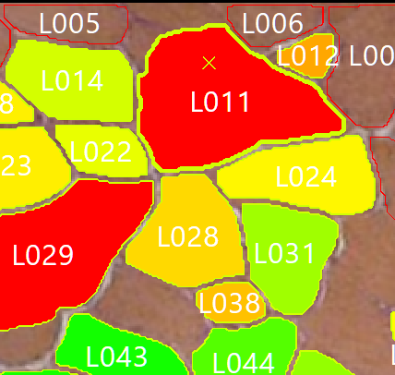
Figure 4: Image Window excerpt displaying and editing nuclei

The detection of nuclei in a cell image is coarse and time-consuming, therefore the user has to explicitly switch it on using the ‘Detect nuclei’ checkbox shown in Figure 5 below.
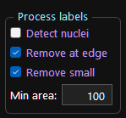
Figure 5: Detect nuclei option in the Process labels group box

The Image Window

Basic Actions
Action | Effect
single left click | Toggles the selection of the clicked ROI.  The selection of other ROIs is not changed
Alt +single left click | Immediately marks the ROI as deleted
right-click  hold & drag  release | “Select within rectangle”: Selects all ROIs that are completely inside the indicated rectangle
Delete key | Marks all selected ROIs as deleted
Esc(ape) key | Deselects all ROIs
Ctrl + Alt +single left click | Add a nucleus here  or  Edit the perimeter polygon of an existing nucleus
Table 4: Basic actions

Tagged delete
The goal of the tagged delete is to facilitate keeping a record of why specific ROIs have been marked as deleted.
When one or more ROIs have been selected and one of the function keys listed in Table 5 is pressed, the selected ROIs are deleted and marked with the text shown in the ‘Tag’ column.
Key pressed | Tag | Artifact
F5 | freeze | The deleted ROIs shows a freeze artifact
F6 | fold | The deleted ROIs shows a folding artifact
F7 | vessel | The deleted is a vessel
F9 | section.tear | The deleted ROIs were torn during section
F10 | section.stretch | The deleted ROIs were stretched during section
Table 5: Tagging artifacts

The Polygon Editor
If the user Ctrl + Alt +single left clicks inside a cell/fiber a nucleus is added at that position, and it is stored as a “child” of the fiber/cell.
If the user Ctrl + Alt +single left clicks on an existing nucleus the Polygon Editor will open.
If the user has clicked a newly created nucleus, the editor will show on regular polygon. The user can then shape the polygon by dragging the vertices to the appropriate position.
Vertices cannot be added or removed using the Polygon Editor.
If the user has clicked an existing polygon, the editor will show the polygon as it was detected by RoiEditor or a previously edited nucleus

- NEW | Action | Effect
 | Window X button | The Polygon Editor is closed and all changes made by the user are discarded
 | ESC key
 | END key | The Polygon Editor is closed and the changes made by the user are stored
 | ENTER key
 | Ctrl + | Zoom in
 | Ctrl - | Zoom out
 | Ctrl 0 | Reset zoom
 | Table 6: Polygon Editor Basic actions

Select outer edge
ROIs at the edge of the photographed object are often damaged or deformed. They can be selected with a single button click on ‘Select outer’. When they are deleted after selection, they are marked with the tag ‘edge.outer’. When one or more ROIs are manually removed from the selection by right-clicking them, the tag is ‘forgotten’ for these ROIs.
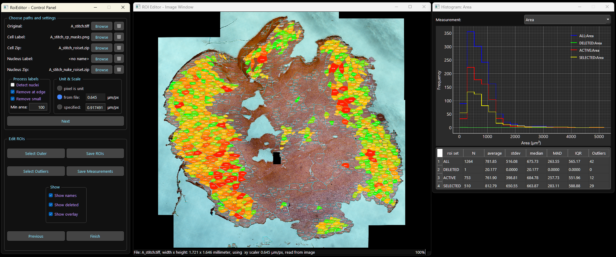
Figure 6: Select outer

The Histogram window
The Histogram window shows the statistics of the 4 subsets of ROIs in real-time.
The Histogram window displays statistics for area and the Feret numbers as shown in Figure 8. The typical shape of a Feret Angle distribution has a bathtub shape due to the cyclical nature of angles. To facilitate the interpretation of the Feret angle an extra measurement has been created, AngleShifted. AngleShifted shows the distribution of the Feret Angle shifted by 90° typically creating a bell-shaped distribution that is easier to interpret. This is shown in Figure 9.
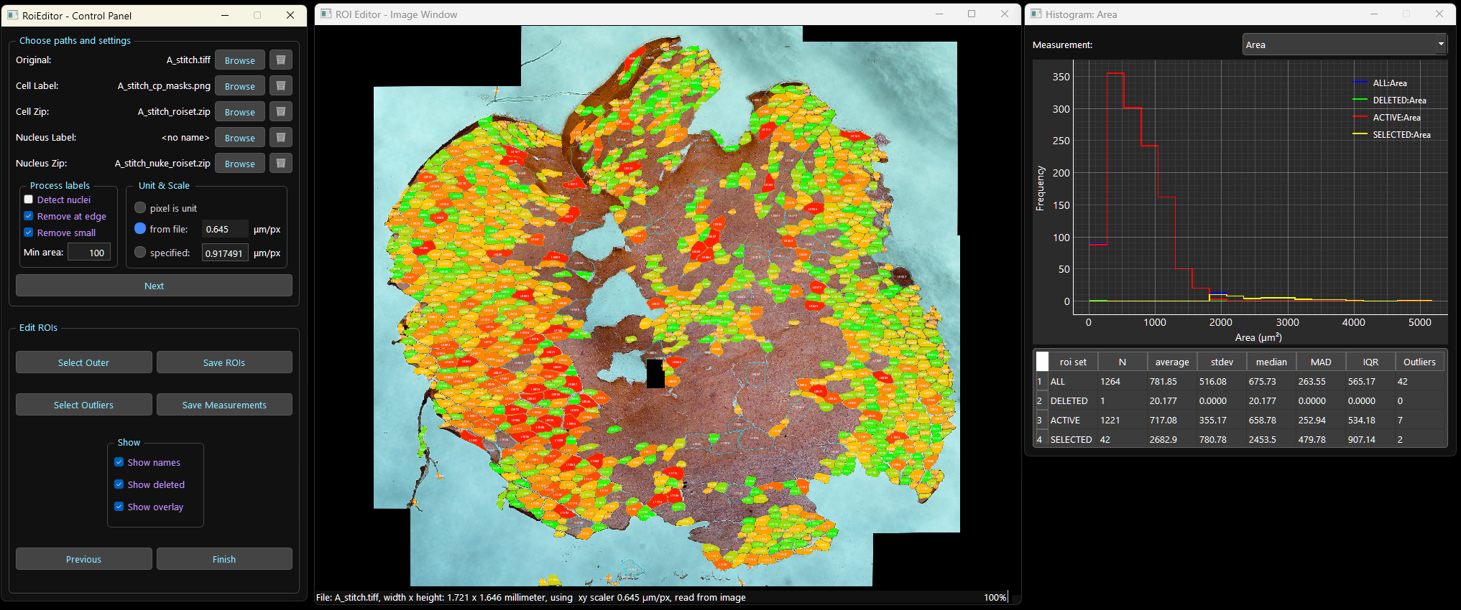
Figure 7: Select outliers

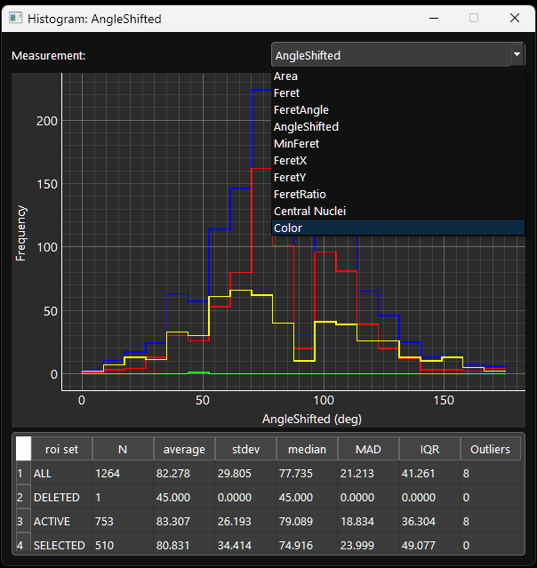
Figure 8: Selecting a measurement

Figure 9: FeretAngle and AngleShifted

Selecting Outliers
When the checkbox ‘Show overlay’ is checked, the ROIs are filled with a color ranging from green to red. Green ROIs have a value for the selected measurement that is close to the median, red ROIs have a value close to or beyond $Q1-1.5 ×IQR or Q3+1.5 ×IQR$.
When the button ‘Select Outliers’ is clicked, all ROIs having a measurement value outside of the range $\left[Q1-1.5 ×IQR, Q3+1.5 ×IQR\right]$ are selected.
When ROIs are deleted after being selected by clicking ‘Select Outliers’, the ROIs are tagged with ‘<measurement name>.outlier’, e.g., ‘Area.outlier’.
The Color measurement shows the Euclidean distance between the RGB color of a cell / fiber and the average color over all cells / fibers in the roi set. For the Color a range of $3.0 ×IQR$ is used.

Output files

ROIs
When RoiEditor writes the zip file it adds a file containing the states and tags to the zip-file. This extra file called ‘tags.json’ may confuse some “Fiji compatible ROI readers/writers”. When this occurs and it is necessary to open the zip in another application: just remove the ‘tags.json’ file.
Contrary to other applications using Fiji ROI format, RoiEditor never removes ROIs from the zip-file: it stores the state (ACTIVE,DELETED,SELECTED), the average RGB color over the cell / fiber and the tags in the ‘tags.json’ file.

Measurement data
The .csv file contains the area and other metrics for all ROIs expressed in pixels, so no unit or scaling is applied.
The .xlsx file contains multiple sheets as explained in Table 7.
Sheet | Content | Unit (*) | This worksheet contains…
pixels_ALL | numbers | pixels | the same data as the .csv file
pixels_ACT | numbers | pixels | the data of the ROIs in ACTIVE state
scalers | numbers | $\left(\frac{μm}{pixel}\right)$ and $\left(\frac{{μm}^{2}}{pixel}\right)$ | the scalers to convert pixels into the correct unit
scaled_ACT | formulas | $μm$ and ${μm}^{2}$ | the result of applying the ‘scalers’ to the data of ‘pixels_ACT’
summary_ACT | formulas | $μm$ and ${μm}^{2}$ | the stats for all metrics of sheet ‘scaled_ACT’
Table 7: xlsx workbook worksheets
(*) 1. some metrics are expressed in degrees (FeretAngle, AngleShifted) or have no unit (FeretRatio)
2. the user may have chosen not to apply a scaling; then the unit is pixels in all rows

Erosion
Unless the ROIs are very clearly separated, cellpose creates neigboring ROIs without any gap in between. When RoiEditor reads the labels from either an .npy or a .png file the algorithms that identify the labels create an open area of 2 pixels between the ROIs. No statistics have been collected to estimate the possible error when ROIs have already been separated by cellpose and RoiEditor widens that gap. Visually the error seems to average out.
When the pixels at the perimeter of a label or ROI are removed or eroded away the impact of removing one row of pixels is:
$$∆ Area$$
$$≅$$
$$\sum{area }of pixels removed$$
$$≅$$
$$perimeter length \left(before removal\right)×pixels size$$
$$≅$$
$$perimeter length \left(after removal\right)×pixels size$$
In the assumption that $Area ≫10 pixels$
Since the perimeter can be calculated only after separating the labels into isolated ROIs, the perimeter length is used as estimator for the impact of eroding 1 pixel all around each ROI.
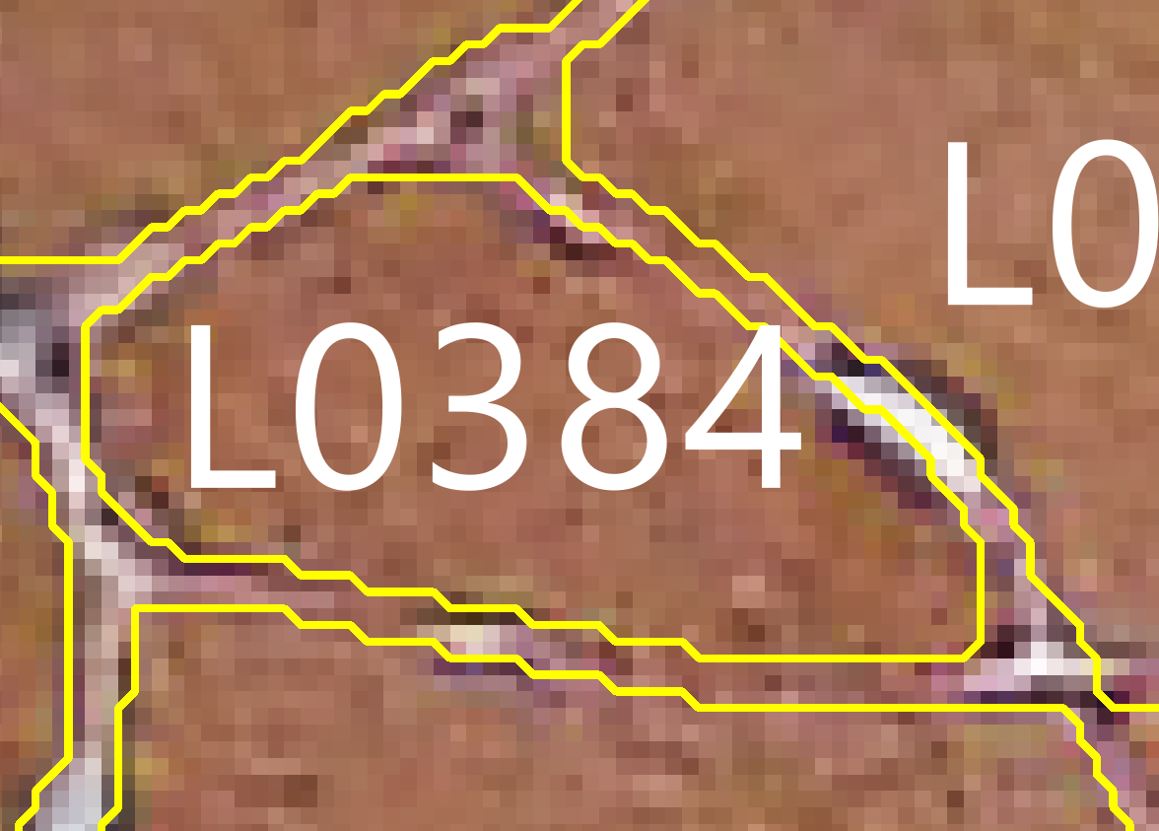
Figure 10: FeretAngle and AngleShifted

Cellpose 3 basics

Installing cellpose 3

- Option 1: regular install using pip
  - Open a Windows command prompt.
  - Type : python -m pip install "cellpose[gui]==3.*" .
  - Cellpose will now be installed. If you freshly installed Python, this may take a while since next to cellpose quite some Python modules need to be installed.
  - If things go wrong both the cellpose GitHub pages and cellpose website offer some help.
- Option 2: cellpose installer in RoiEditor zip
  - An installer for cellpose can be found in the RoiEditor zip package.
To use that installer, first execute step 2. until 5. of section 1.1 on page 2.
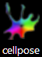
  - Double-click install_cellpose.bat
  - The script will install a desktop shortcut for cellpose too:

Remove at edge
Only the ROIs that touch the outer rectangle are removed. The cells around the cut-out rectangle are not removed.
The ROIs touching the black rectangle can easily be removed using “Select within rectangle” described in Table 4 on page 7.
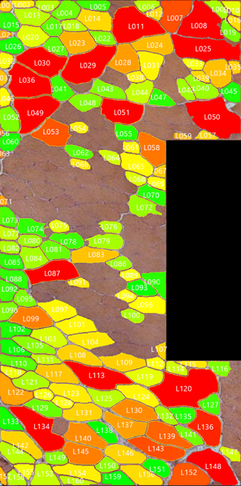 | 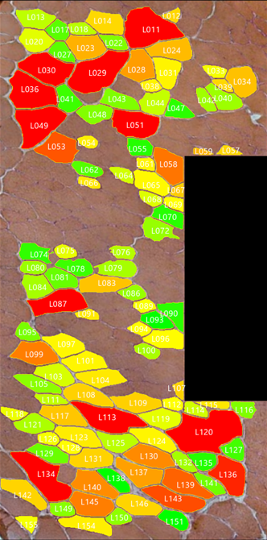
Figure 11: Removing the edge of an image


Using cellpose 3
If you have a desktop icon for cellpose, just double click the icon:
Alternatively start cellpose, following the steps below:
- open a Windows command prompt.
- Do not start Python, but type python -m cellpose
- Now you need to open a photograph. Open the photograph using the menu File>Load ( (A) in Figure 12).
- Preferably do not change any settings, just make sure that in the lowest groupbox ‘Image Restoration’ cyto3 is selected.
- Now click the ‘run cyto3’ button in the groupbox ‘Segmentation’.
- When the segmentation has finished, the photo will be overlayed with the identified ROIs.
- Now you can save the results in several file formats. The three file formats RoiEditor can import are shown in Figure 12 and Table 8.
 |  | *_seg.npy | This is a Python numpy specific file format. It contains more data than II and III, but does not offer extra info for RoiEditor
 |  | PNG/tif | Although this is a regular picture format, most picture editors will not properly display this file. It is only used to transfer data to another application, not for visual inspection.
 |  | .zip | The zip archive is a fileformat that is compatible with Fiji. It is the same fileformat used by RoiEditor to store the results after removing ‘bad’ ROIs
 |  | Table 8: file formats supported by RoiEditor 2.0
Figure 12: Reading and writing files

Figure 13: cellpose and RoiEditor Workflow
Cellpose 3’s nucleus detection does not work for mice muscle fibers, Cellpose 4 does no longer offer nucleus detection.


RoiEditor 3.0 Cheat Sheet

  - Basic Actions
Action | Effect
single left click | Toggles the selection of clicked ROI.  The selection of other ROIs is not changed
Alt + left click | Immediately marks the ROI as deleted
right-click  hold & drag  release | Selects all ROIs inside the indicated rectangle
Delete key | Marks all selected ROIs as deleted
Esc(ape) key | Deselects all ROIs
Ctrl + Alt + left click | Add a nucleus here  or  Edit the perimeter polygon of a nucleus
  - Tagging
Select the ROIs to be deleted and then press:
Key | Tag | Artifact
F5 | freeze | The deleted ROIs shows a freeze artifact
F6 | fold | The deleted ROIs shows a folding artifact
F7 | vessel | The deleted is a vessel
F9 | section.tear | The deleted ROIs were torn during section
F10 | section.stretch | The deleted ROIs were stretched during section
  - Polygon Editor
Action | Effect
Window X button | The Polygon Editor is closed; changes are discarded
ESC key
END key | The Polygon Editor is closed; changes are stored
ENTER key
Ctrl + | Zoom in
Ctrl - | Zoom out
Ctrl 0 | Reset zoom

Contents
1.1 Installation on Windows 2
1.2 Get the zip 2
1.3 Start a command prompt 2
1.4 Checking what’s already installed 2
1.5 Install Python.bat 2
1.6 Install RoiEditor 3
1.7 Check the installation 3
2 Using RoiEditor 3
2.1 Use 3
2.2 Start RoiEditor 3
2.3 Select the files 4
2.3.1 Autocompletion 4
2.3.2 Two in one go 4
2.3.3 The checkboxes & radio buttons 4
2.3.4 Next 5
2.4 Editing ROIs 6
2.4.1 The Image Window 7
2.4.2 The Polygon Editor 8
2.4.3 The Histogram window 9
2.4.4 Selecting Outliers 10
2.5 Output files 11
2.5.1 ROIs 11
2.5.2 Measurement data 11
2.6 Erosion 12
3 Cellpose 3 basics 13
3.1 Installing cellpose 3 13
3.2 Using cellpose 3 15
4 Remove at edge 14

